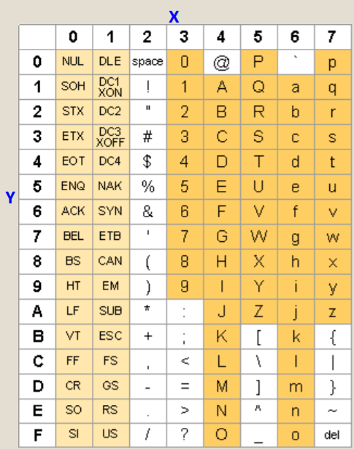

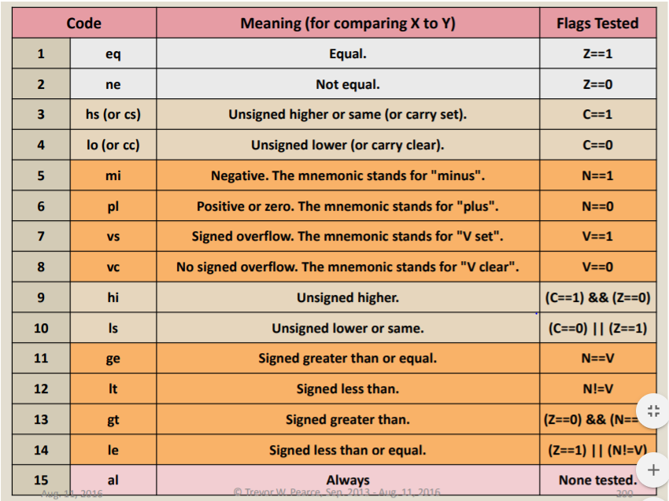

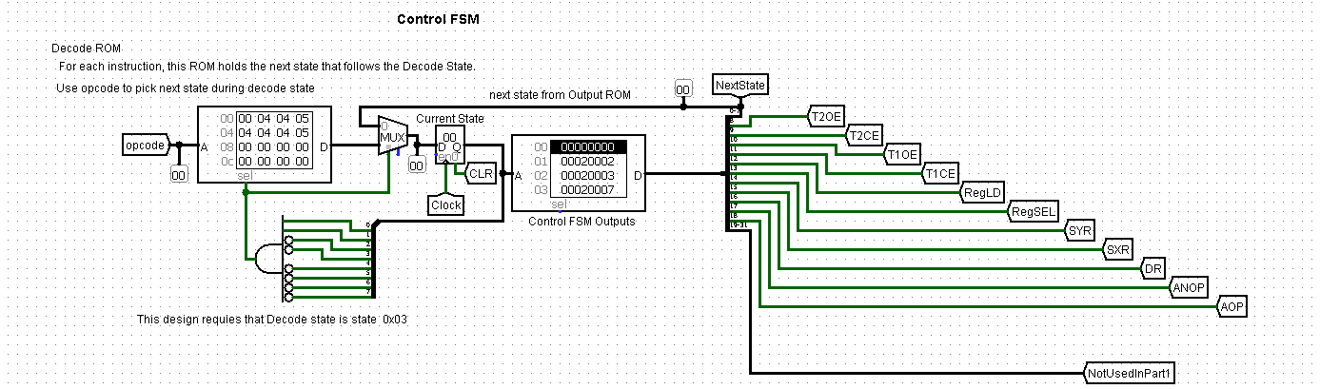

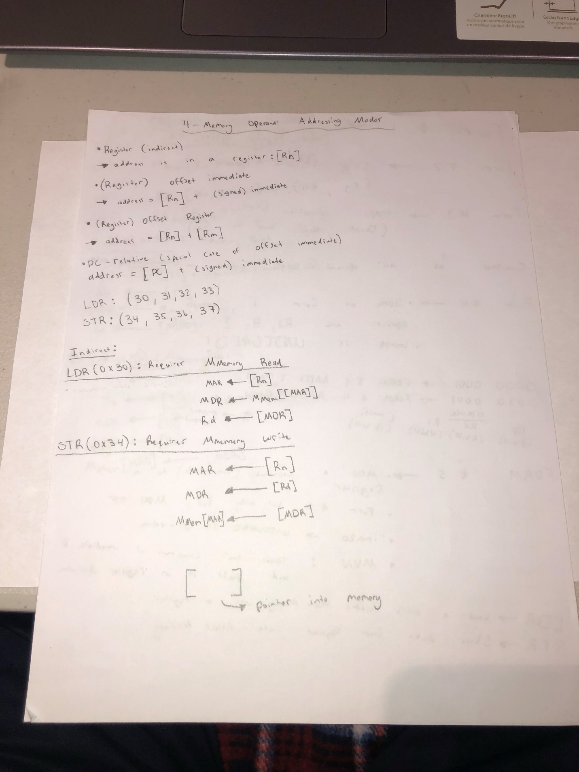

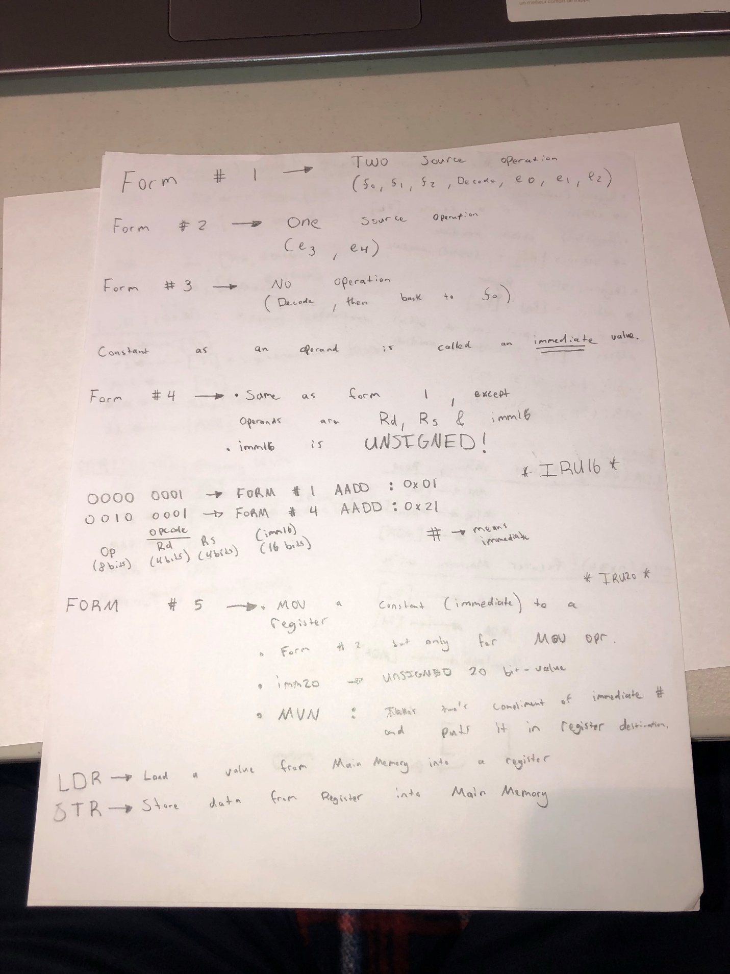

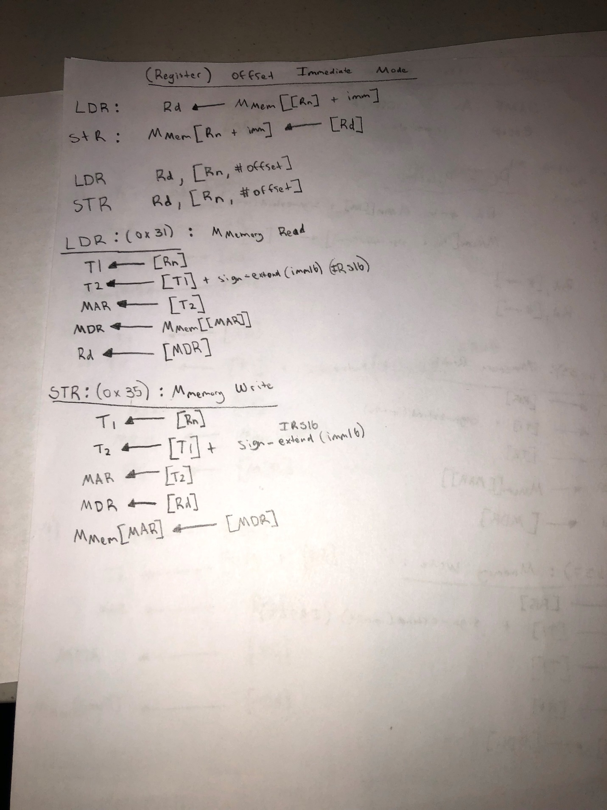

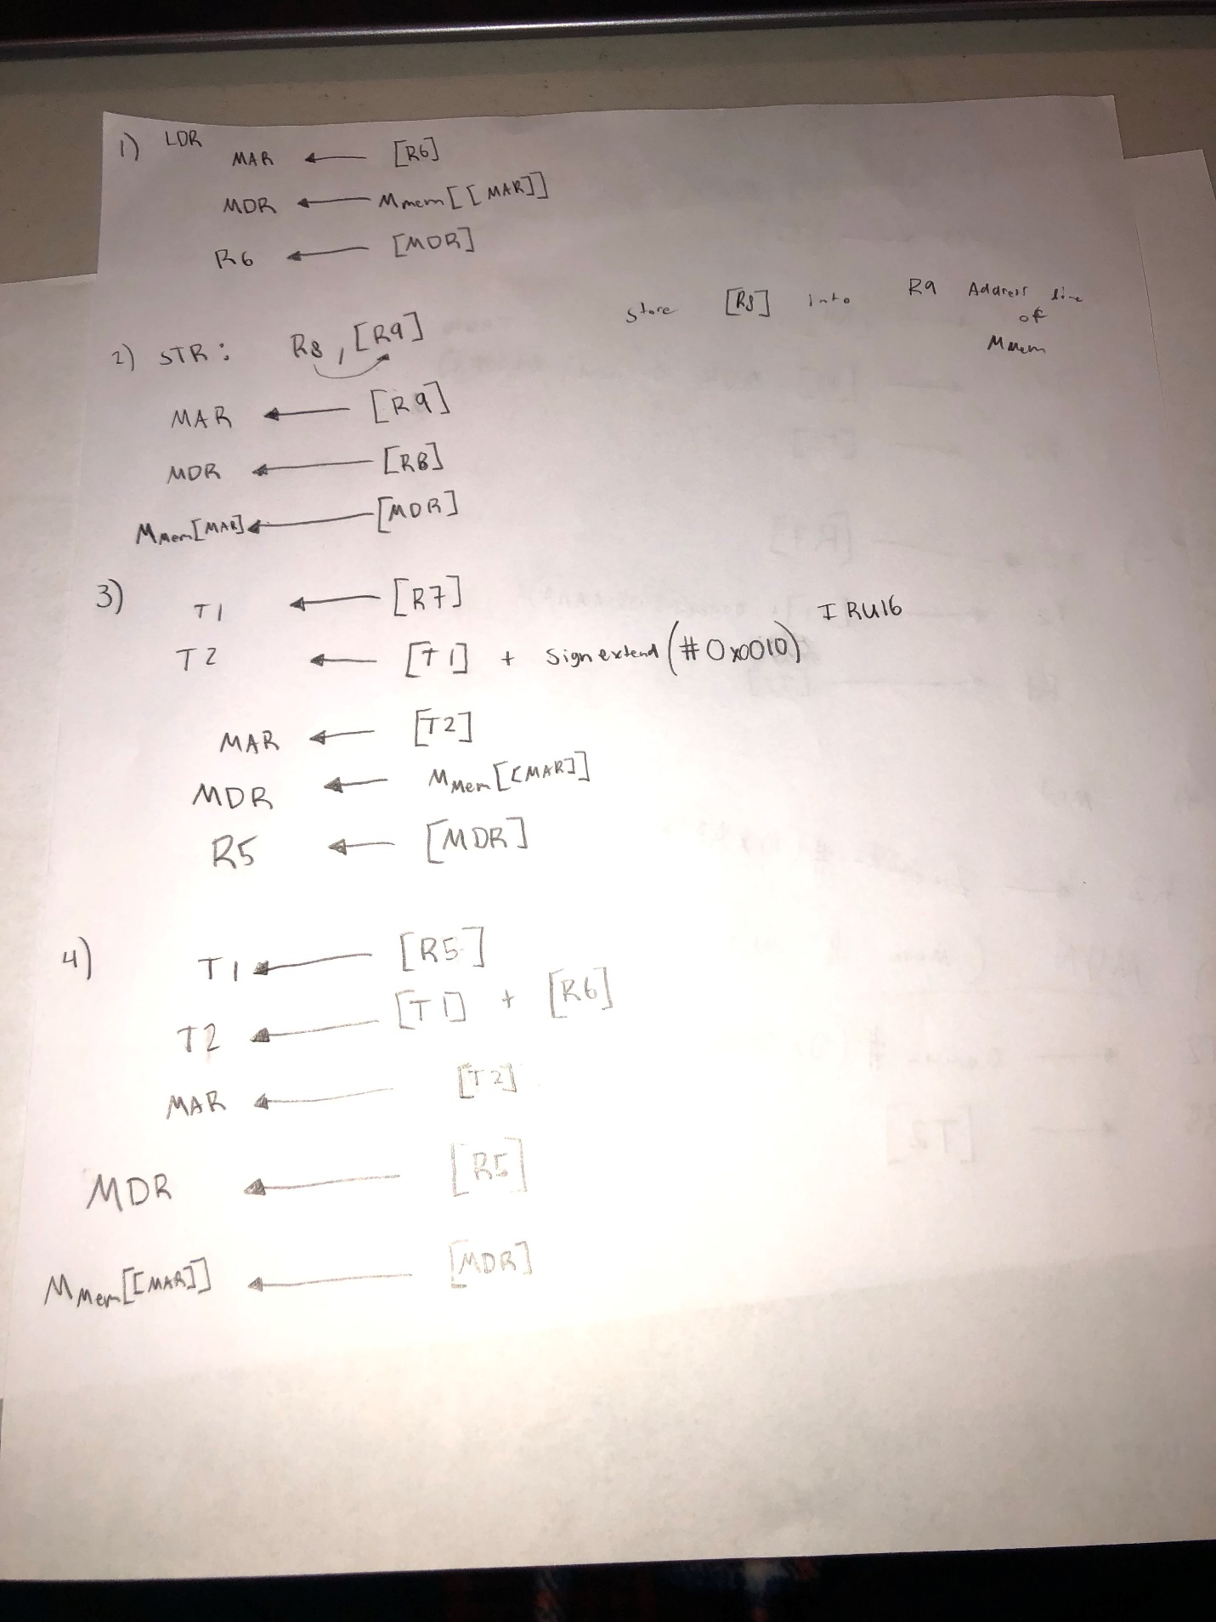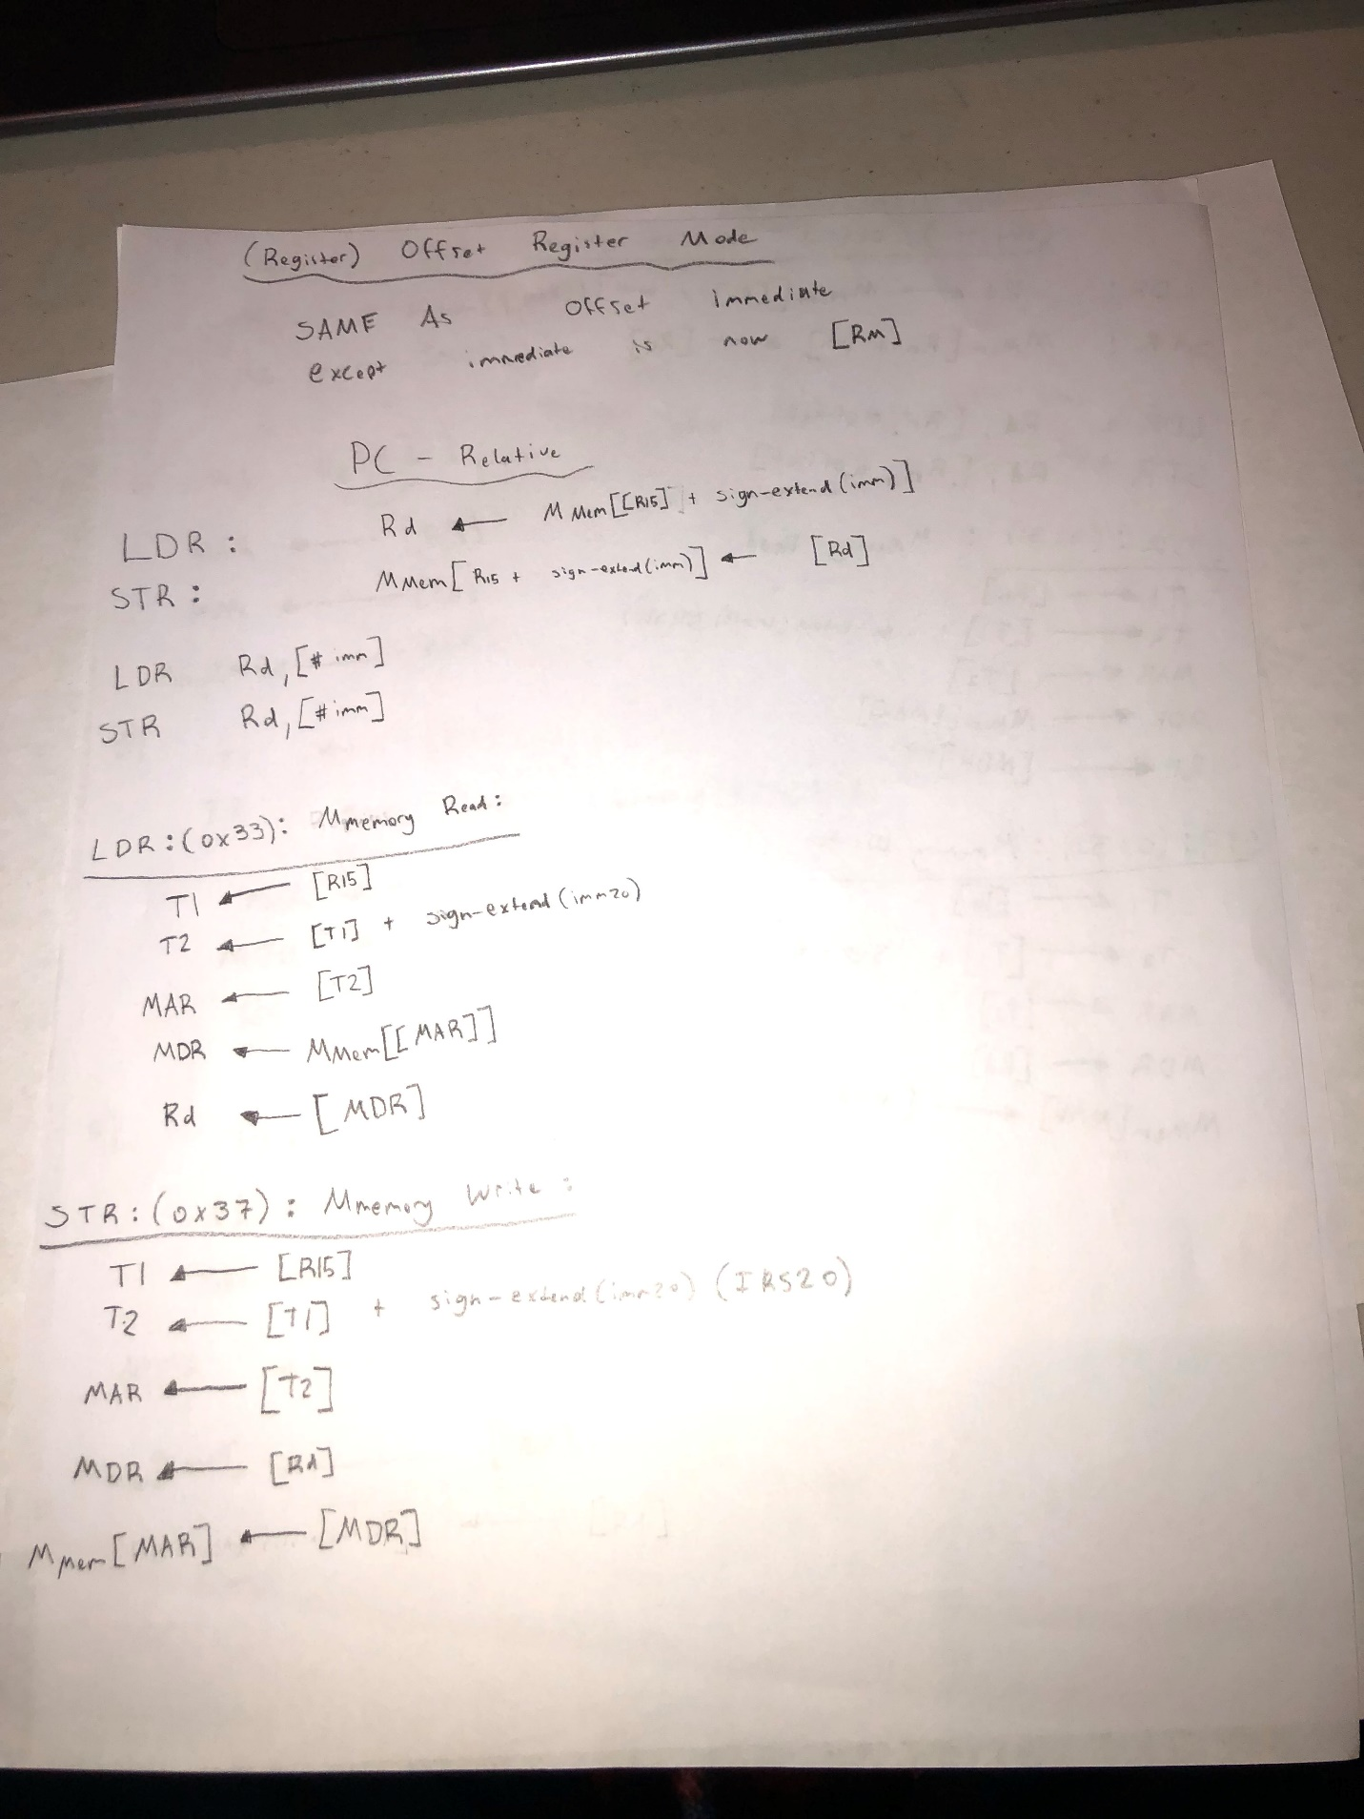

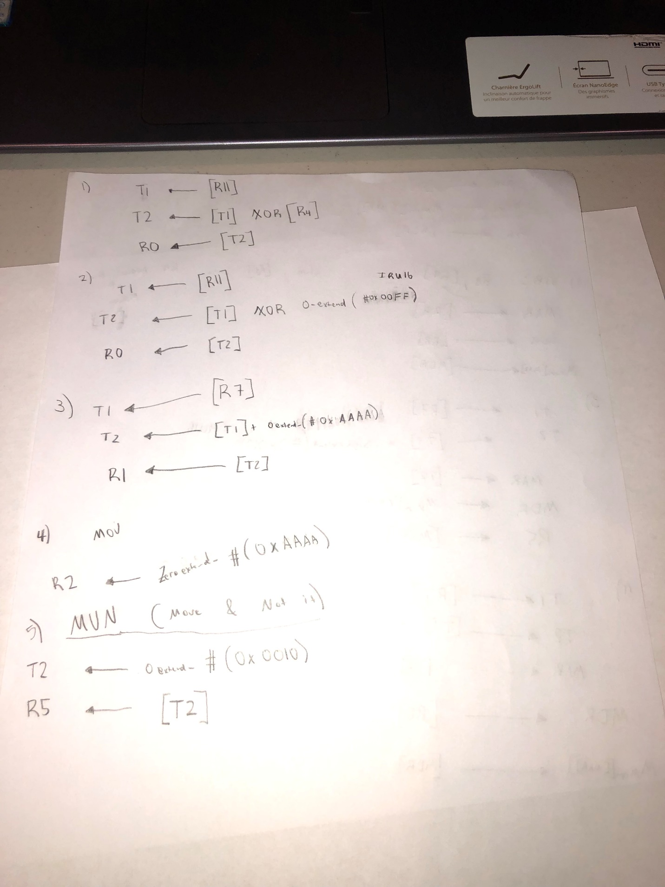

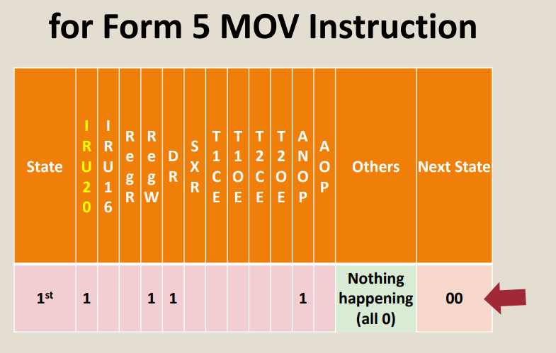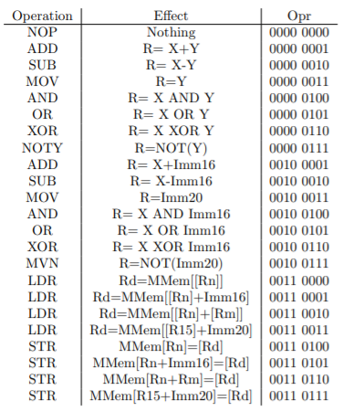

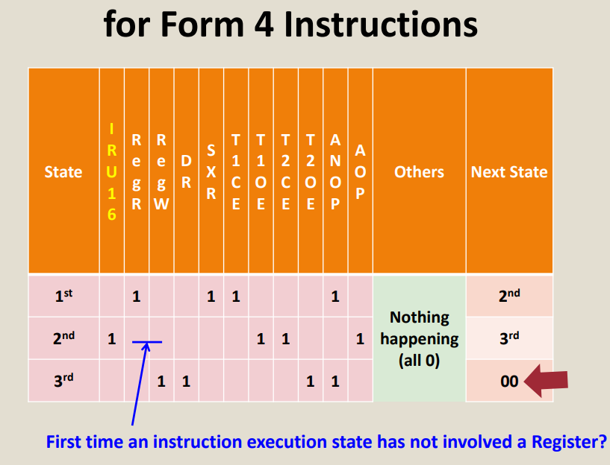  
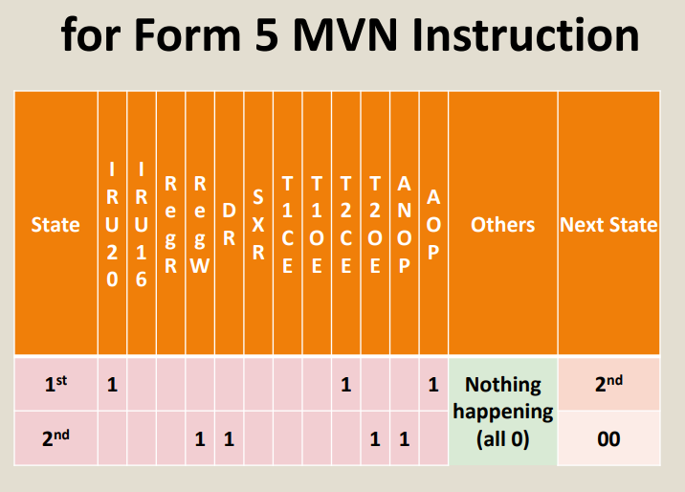  
  
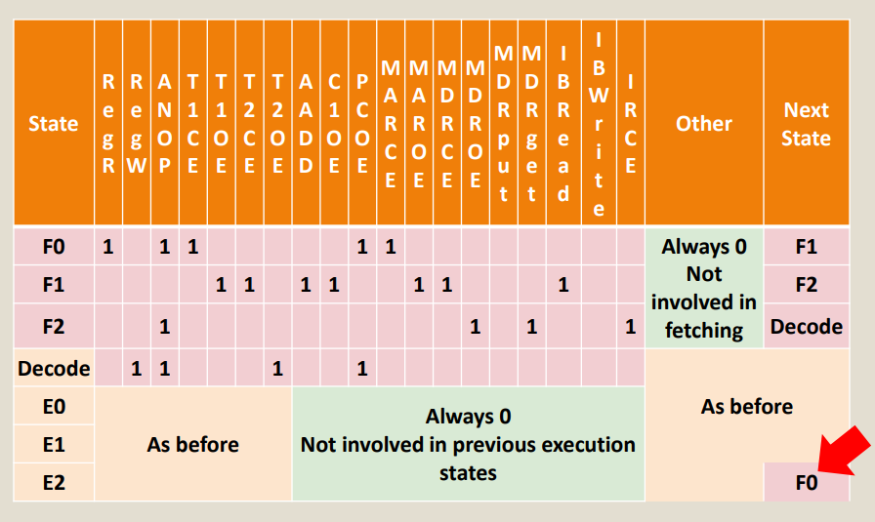  
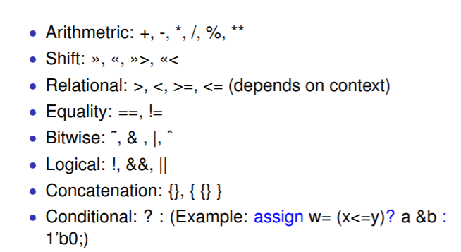

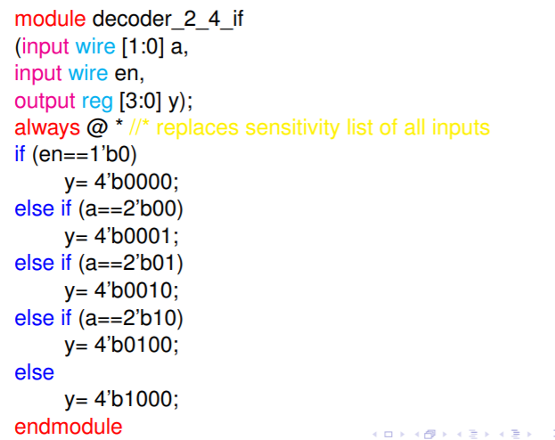

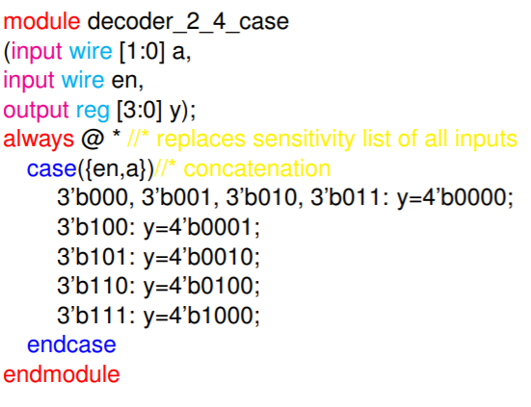

^ how to initialize another module

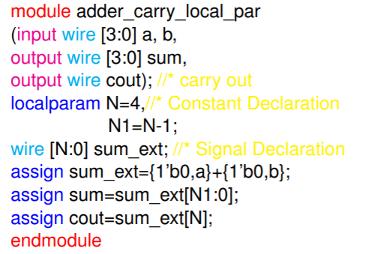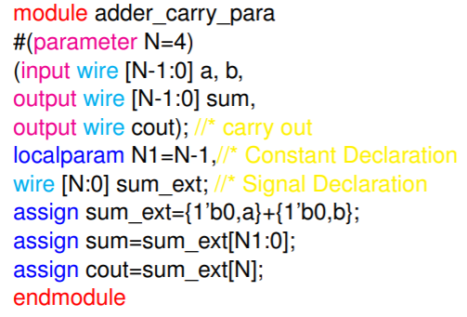

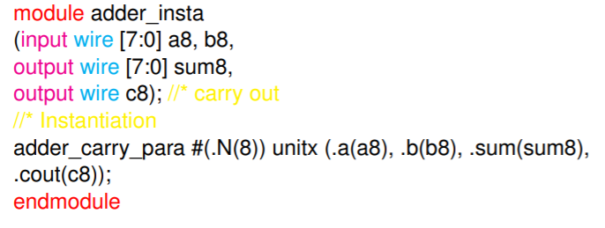

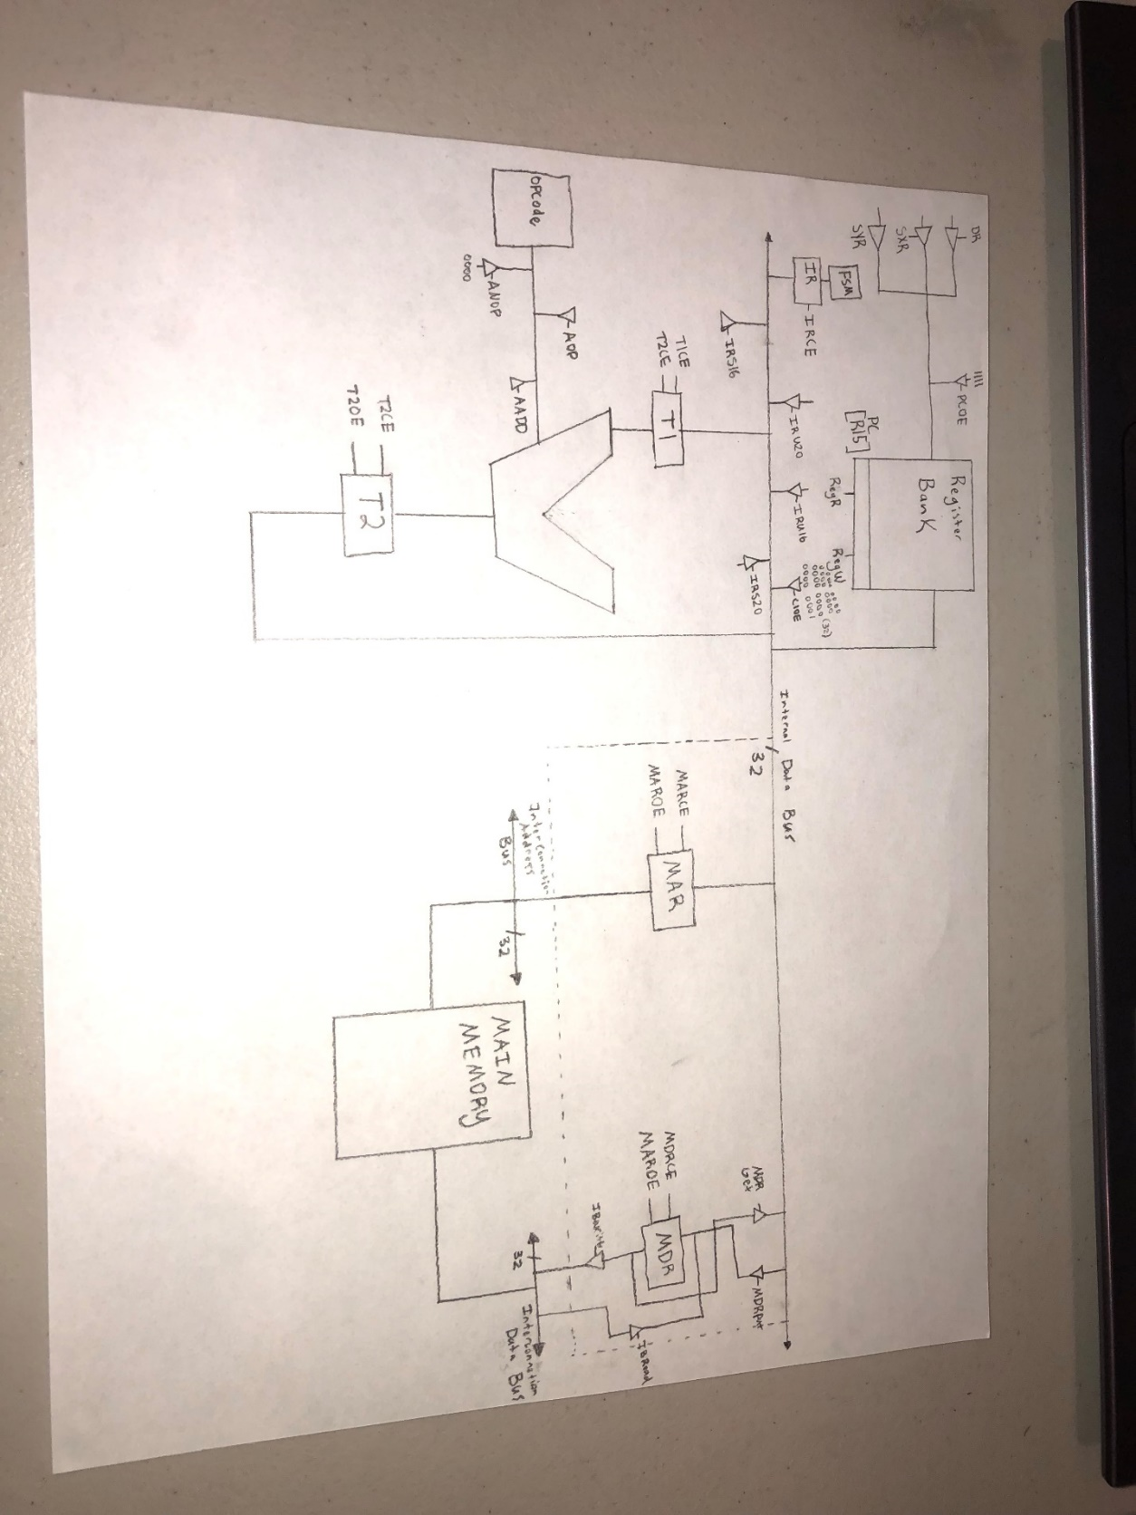

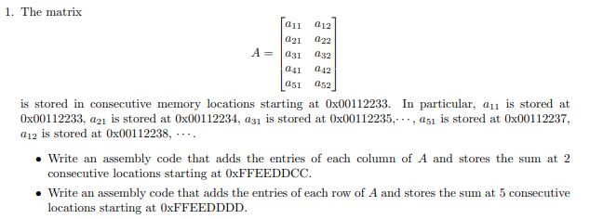  
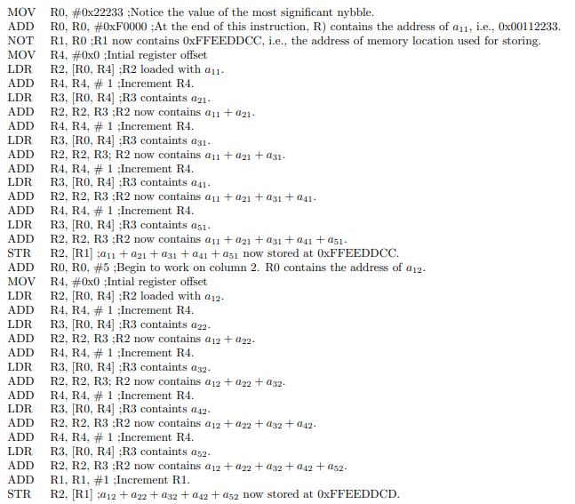  
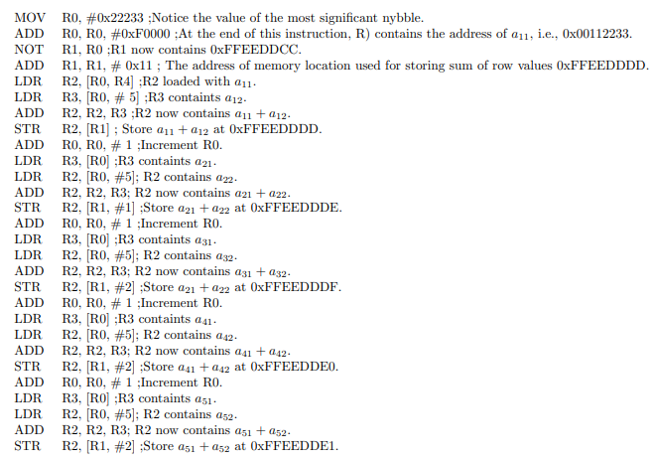

**For-Loop**

for(int i = 0; i < array.size; i++){

}

**Assembly:**

R7 = i; (counter)

R5 = array size

**Assembly Language:**

MOV R7, #0; i = 0

DoFor; label (marks beginning of loop)

CMP R7, R5

BHS DoneFor; i < array size (will exit loop if condition sat.)

// for-loop body

ADD R7, R7, #1; i++

BAL DoFor; Branch back to the beginning of loop

DoneFor; used to take you out of loop

**if statement**

int i = 1;

if(i == 5){

}

**Assembly:**

R7 = i; variable

**Assembly Language:**

MOV R7, #1

CMP R7, #5

BNE DoneIf

//if body

DoneIf

**while-Loop**

Int i = 0;

while(i < arraysize){

I++;

}

**Assembly:**

R7 = i; (counter)

R5 = array size

**Assembly Language:**

MOV R7, #0

DoWhile

CMP R7, R5

BHS EndWhile

//while loop body

ADD R7, R7, #1

BAL DoWhile

EndWhile

**Array Search**

R6 = – 1; // initially, the value has not yet been found

for (R7 = 0; R7 < R5; R7++ ){ // R5 == array size

if (array[ R7 ] == R3 ){ // found!

R6 = R7; // save index

break; // exit loop

}

}

**Assembly:**

R7 = i; (counter)

R6 = desired Index

R5 = array size

R3 = Value of interest

R4 = Address of start of array

**Assembly Language:**

MVN R6, #0

MOV R7, #0

DoFor

CMP R7, R5; R7 < R5

BHS DoneFor; R7 >= R5

LDR R8, [R4, R7]; [R4, R7] = Array[R7], R8 = Array[R7]

CMP R8, R3

BNE EndIf

MOV R6, R7

BAL DoneFor

EndIf

ADD R7, R7, #1

BAL DoFor

DoneFor

11 Words, 3 Branches

**WORDS =** LINES THAT DO SOMETHING (NO SINGLE LINED LABELS BY THEMSELVES)

**BRANCHES =** LABELS

**BETTER VARIATION**

MVN R6, #0 ; R6 = – 1

MVN R7, #0 ; initialize loop R7 = – 1 then inc

IncR7 ADD R7,R7,#1 ; R7++ ← moved to here!

TestForDone CMP R7, R5 ; R7 < R5?

BGE DoneFor ; No – done!

LDR R8, [R4,R7] ; get element array[R7]

CMP R8, R3 ; element == value of interest?

BNE IncR7 ; No – continue in loop

MOV R6, R7 ; Yes – save index

DoneFor ; continue

9 WORDS, 2 BRANCHES

**STR R6, [R4,#0] ; array[0] = [R6]**

**LDR R6, [R4, #0] ; R6 = array[0]**

**STORE MEANS STORE TO MAIN MEMORY**

**LOAD MEANS LOAD FROM MAIN MEMORY**

